**CLIMATE CHANGE INSIGHTS: GRAPHICAL DATA REPRESENTATION AND ANALYSIS**

**ABSTRACT**

Climate change, driven by factors such as greenhouse gas emissions, deforestation, and industrial activities, has become one of the most pressing global challenges of our time. Its impacts are wide-ranging, affecting weather patterns, sea levels, and biodiversity. Accurate data representation and analysis of climate-related variables are crucial for understanding and mitigating these impacts. Historically, climate data collection and analysis have relied on manual measurements and early technological advancements. With the advent of satellite technology and advanced data collection methods, the volume and precision of climate data have significantly improved. The central problem in climate change analysis is the effective representation and interpretation of large, multidimensional datasets. Traditional methods often struggle to provide clear insights due to their inability to handle complex data relationships and visualize trends comprehensively. This gap highlights the need for more sophisticated analytical tools and techniques that can offer a more nuanced understanding of climate variables and their interactions. Traditional climate analysis systems typically involve basic statistical methods and manual data processing. These systems often fail to capture the dynamic nature of climate data and lack the capability to handle real-time data integration. Limitations include inadequate handling of high-dimensional data, lack of interactive visualization capabilities, and insufficient tools for exploring complex relationships between variables. Addressing these limitations is crucial for developing more effective climate change mitigation and adaptation strategies. Enhanced graphical data representation and analysis can facilitate better understanding of climate trends, identify key patterns, and support informed decision-making. By leveraging advanced visualization techniques, such as heatmaps, scatter plots, and time series analysis, researchers and policymakers can gain deeper insights into climate dynamics and the effects of various interventions.

**CHAPTER 1**

**INTRODUCTION**

**1.1 History**

The history of climate data collection and analysis reflects a journey from rudimentary methods to sophisticated technologies, mirroring advancements in science and technology over the centuries. In the early days, climate data was gathered through manual observations. Instruments like thermometers and barometers were used to measure temperature and atmospheric pressure. These early measurements were essential but limited in scope and accuracy due to the lack of advanced calibration techniques and the constraints of early technology.

As the 19th century progressed, the development of more precise instruments and the establishment of meteorological networks marked significant advancements. Scientists began systematically recording weather conditions, which led to the creation of weather maps and early climate models. The invention of the telegraph allowed for the rapid transmission of weather data over long distances, enabling more comprehensive weather forecasting.

The mid-20th century ushered in a new era with the advent of satellite technology. Satellites revolutionized climate data collection by providing a global perspective on weather patterns, sea levels, and atmospheric conditions. They offered unprecedented accuracy and coverage, capturing data from remote and previously inaccessible regions. This era also saw the emergence of computer-based models that could simulate complex climate systems and predict future changes with greater precision.

Despite these advancements, traditional methods continued to play a role in climate analysis. Researchers relied on a combination of satellite data, ground-based observations, and historical records to understand climate trends. However, as the volume of data grew, it became apparent that existing analytical tools were insufficient for managing and interpreting large, multidimensional datasets.

In recent years, the focus has shifted toward integrating real-time data with advanced analytical techniques. Big data analytics and machine learning have started to play a crucial role in processing and interpreting climate data. These modern approaches aim to handle the complexity and volume of data generated by satellite observations and other sources, offering more detailed and actionable insights.

The history of climate data collection and analysis illustrates the evolution from simple measurements to complex, integrated systems. Each phase in this history has contributed to our understanding of climate change, laying the foundation for more advanced methods and technologies that continue to drive the field forward.

**1.2 Research Motivation**

The motivation behind researching advanced climate data analysis techniques stems from the increasing urgency to address the impacts of climate change. As climate-related phenomena become more pronounced and widespread, the need for precise and actionable insights into climate variables has never been greater. Traditional methods of climate analysis, while foundational, struggle to keep pace with the growing complexity of data and the demands of modern climate science.

The primary motivation for this research is to bridge the gap between the vast amounts of climate data available and the need for effective, nuanced analysis. The explosion of data from satellite observations, ground-based sensors, and other sources presents both opportunities and challenges. While these data sources provide a wealth of information, they also create significant hurdles in terms of processing, interpretation, and visualization.

Advanced analytical techniques offer the potential to overcome these challenges by providing more sophisticated tools for handling high-dimensional data. Machine learning algorithms, for instance, can identify patterns and trends that might be missed by traditional statistical methods. Visualization tools, such as interactive graphs and heatmaps, can reveal complex relationships between climate variables, facilitating a deeper understanding of climate dynamics.

Another key motivation is to enhance decision-making and policy formulation. Accurate and timely insights into climate trends are crucial for developing effective mitigation and adaptation strategies. Researchers, policymakers, and environmental organizations need tools that can translate raw data into actionable information. By improving data representation and analysis, this research aims to support better decision-making and contribute to more effective climate action.

Furthermore, the growing impact of climate change on various sectors, including agriculture, water resources, and public health, underscores the need for advanced analytical approaches. Understanding how climate variables interact and affect different aspects of society can help in designing targeted interventions and strategies.

**1.3 Problem Statement**

The central problem in climate change analysis is the effective representation and interpretation of large, complex datasets that encompass a wide range of climate variables. As climate science has evolved, the volume and complexity of data have increased significantly, presenting challenges for traditional analytical methods.

Traditional climate analysis systems often rely on basic statistical methods and manual data processing. These approaches are limited in their ability to handle high-dimensional data, integrate real-time information, and visualize complex relationships between variables. As a result, they may struggle to provide clear and actionable insights into climate trends and patterns.

One of the main issues is the inability of traditional systems to manage and process the vast amounts of data generated by modern climate observation technologies. Satellite data, ground-based sensors, and historical records create a multidimensional dataset that is challenging to analyze with conventional tools. This gap highlights the need for more sophisticated analytical methods that can handle large datasets and extract meaningful insights.

Another challenge is the lack of advanced visualization capabilities in traditional systems. Effective visualization is crucial for understanding complex data relationships and trends. Traditional methods may fall short in providing interactive and dynamic visualizations that allow for exploration and analysis of data from different perspectives.

Moreover, traditional systems often lack the ability to integrate real-time data with historical records, which is essential for tracking and responding to rapidly changing climate conditions. The dynamic nature of climate data requires analytical tools that can accommodate real-time updates and provide timely insights.

**1.4 Need and Significance**

* **Enhanced Understanding of Climate Trends:** Advanced analytical techniques are essential for gaining a deeper understanding of climate trends and patterns. Traditional methods often fall short in capturing the nuances of complex data relationships. Improved analytical tools can reveal hidden patterns and interactions between climate variables, leading to more accurate and comprehensive insights.
* **Informed Decision-Making:** Decision-makers require precise and actionable information to develop effective climate change mitigation and adaptation strategies. Enhanced data representation and analysis enable better decision-making by providing clear insights into climate dynamics and the effects of various interventions. This can support the development of targeted policies and strategies.
* **Real-Time Monitoring and Response:** The ability to integrate and analyze real-time data is crucial for monitoring climate conditions and responding to rapid changes. Advanced analytical methods can handle real-time updates, allowing for timely interventions and adjustments to climate action plans.
* **Improved Visualization Capabilities:** Traditional visualization tools may lack the capability to effectively represent complex climate data. Advanced visualization techniques, such as interactive graphs and heatmaps, provide a more intuitive and detailed understanding of data, facilitating better interpretation and communication of findings.
* **Supporting Climate Science Research:** Researchers need sophisticated tools to explore and analyze climate data effectively. Enhanced analytical methods contribute to advancing climate science by enabling more detailed and accurate analyses of climate variables and their interactions.
* **Addressing Sector-Specific Impacts:** Climate change affects various sectors, including agriculture, water resources, and public health. Advanced data analysis techniques can provide insights into how climate variables impact different sectors, supporting the development of sector-specific strategies and interventions.
* **Promoting Public Awareness:** Improved data representation and analysis can help in communicating climate change impacts to the public and stakeholders. Clear and engaging visualizations make complex data more accessible, raising awareness and fostering a better understanding of climate issues.

**1.5 Applications**

* **Climate Policy Formulation:** Advanced data analysis techniques are used to develop and refine climate policies. By providing detailed insights into climate trends and patterns, these techniques support policymakers in creating effective mitigation and adaptation strategies.
* **Environmental Monitoring:** Real-time data analysis enables continuous monitoring of environmental conditions. This application is crucial for tracking changes in climate variables, such as temperature and precipitation, and assessing their impacts on ecosystems.
* **Agricultural Management:** Climate data analysis helps in managing agricultural practices by providing insights into weather patterns, precipitation, and temperature trends. This information supports crop planning, irrigation management, and risk assessment.
* **Disaster Preparedness:** Advanced analysis of climate data can improve disaster preparedness and response. By identifying trends and patterns related to extreme weather events, such as hurricanes and floods, this application supports the development of early warning systems and emergency response plans.
* **Public Health:** Climate data analysis is used to study the impacts of climate change on public health. By examining relationships between climate variables and health outcomes, researchers can identify potential risks and develop strategies to address them.
* **Urban Planning:** Insights from climate data analysis support urban planning efforts by providing information on how climate variables affect cities. This application helps in designing resilient infrastructure, managing heat islands, and planning for future climate conditions.
* **Educational Resources:** Advanced visualizations and data analysis tools are used to create educational resources that enhance understanding of climate change. These resources support teaching and learning about climate science and its implications.

**CHAPTER 2**

**LITERATURE SURVEY**

Bayes et al. [1] proposed a research agenda for enhancing climate change communication and public opinion by focusing on the role of scientific consensus messaging. Their study emphasized the need for effective communication strategies that move beyond simple consensus messages to address broader public engagement with climate change issues. The authors highlighted that scientific consensus alone is not sufficient to shift public attitudes or motivate action, suggesting a more nuanced approach to communication. Pew Research Center [2] presented findings on how citizens in advanced economies are increasingly willing to alter their lifestyles in response to climate change. The report indicated that despite a general willingness to make changes, the specific actions and commitments varied widely across different regions and demographics. This study provided valuable insights into the attitudes and behaviors of individuals regarding climate action. Brosch [3] reviewed how affect and emotions influence climate change perception and action. The author argued that emotional responses play a critical role in shaping individuals' views on climate change and their willingness to take action. The review synthesized various studies to highlight the importance of addressing emotional factors in climate change communication strategies.

Markman [4] examined why people often lack motivation to address climate change, despite being aware of its impacts. The article discussed psychological and behavioral barriers that hinder effective climate action and proposed potential strategies to overcome these challenges. The author emphasized the need for targeted interventions to enhance motivation and engagement. Joslyn and Demnitz [5] explored how explanations of CO2's atmospheric persistence affect attitudes toward climate change. Their study found that providing clear information about the long-term effects of CO2 can influence individuals' understanding and concern about climate change. The authors suggested that better communication of scientific concepts can improve public attitudes and support for climate policies. Head [6] discussed the concept of "wicked problems" in public policy, including climate change. The article outlined the complexities and uncertainties associated with wicked problems and proposed approaches for addressing these challenges in policy-making. The author highlighted the need for adaptive and collaborative strategies in managing complex issues like climate change. Johansson et al. [7] evaluated climate visualization techniques using an information visualization approach. The study assessed various methods for presenting climate data visually and their effectiveness in conveying complex information to different audiences. The authors advocated for improved visualization techniques to enhance public understanding of climate change impacts.

O’Neill and Smith [8] investigated the role of visual imagery in climate change communication. The article reviewed how visual representations can influence public perceptions and engagement with climate issues. The authors emphasized the importance of using effective visual tools to communicate climate science and motivate action. Mann [9] authored a book discussing the "hockey stick" climate model and the associated climate wars. The book provided a detailed analysis of the controversy surrounding the model and its implications for climate science communication. Mann’s work highlighted the challenges of communicating climate change in the face of skepticism and misinformation. Schneider [10] examined climate model simulation visualization from a visual studies perspective. The study focused on how visual representations of climate models can impact public and scientific understanding of climate projections. Schneider proposed approaches for improving the clarity and effectiveness of climate model visualizations. IPCC [11] presented the Summary for Policymakers in the Climate Change 2021 report, outlining key findings from the Sixth Assessment Report. The summary provided an overview of the latest scientific understanding of climate change, its impacts, and proposed mitigation strategies. This report serves as a crucial resource for policymakers and stakeholders.

Böttinger et al. [12] reflected on visualization practices for broad audiences, discussing strategies for making data visualization accessible and engaging. The authors highlighted the importance of tailoring visualizations to diverse audiences and contexts to improve understanding and communication. Lee et al. [13] explored methods for reaching broader audiences with data visualization. The study examined various techniques and approaches for enhancing the effectiveness of visualizations in conveying complex data to non-expert audiences. The authors proposed strategies for improving accessibility and engagement. Peck et al. [14] investigated attitudes and perceptions of data visualization in rural Pennsylvania. The study examined how local communities interact with and interpret data visualizations, highlighting the need for contextually relevant visualizations that resonate with specific audiences.

Burns et al. [15] studied the impact of metadata on communicative data visualization. The authors found that incorporating metadata can significantly enhance the clarity and effectiveness of visualizations, making data more comprehensible and meaningful to users.

Park et al. [16] developed Graphoto, a tool for creating aesthetically pleasing charts for casual information visualization. The study focused on improving the visual appeal and usability of charts to enhance casual information engagement and understanding. Kennedy and Hill [17] explored the emotional aspects of engaging with data and its visualization. The authors discussed how emotions influence individuals' interactions with data and proposed approaches for incorporating emotional factors into visualization design. Sprague and Tory [18] modeled user goals and motivations in casual visualization contexts. Their research provided insights into why people use visualizations in everyday life and how to design visualizations that align with user needs and objectives. Pousman et al. [19] examined casual information visualization and its role in everyday life. The study explored how people use visualizations for personal and informal purposes, highlighting the importance of designing visualizations that are both accessible and useful in casual settings.

Lee et al. [20] developed the Visualization Literacy Assessment Test (VLAT) to evaluate individuals' understanding of data visualizations. The test aimed to assess visualization literacy and provide insights into how effectively people can interpret and utilize visual data representations.

**CHAPTER 3**

**EXISTING SYSTEM**

Traditional systems for climate data analysis primarily rely on manual measurement techniques and basic statistical methods. Historically, climate scientists have used instruments like thermometers, barometers, and rain gauges to collect data on temperature, atmospheric pressure, and precipitation. This data was recorded manually and analyzed using fundamental statistical techniques to identify trends and patterns. The analysis was often limited to simple linear models and basic graphical representations such as charts and graphs.

Meteorological stations and networks played a critical role in gathering data over time, providing valuable insights into long-term climate trends. These systems typically involved a combination of ground-based observations and early forms of meteorological instrumentation. As technology advanced, meteorological networks expanded, and more sophisticated instruments were introduced. Despite these improvements, traditional systems remained constrained by their reliance on manual data collection and basic analytical methods.

The integration of satellite technology and computer-based models represented significant advancements in climate data analysis. Satellites provided a broader and more detailed view of climate variables, capturing data from remote and previously inaccessible areas. Early computer models allowed scientists to simulate climate systems and predict future conditions. However, these models were often limited in their ability to handle large datasets and complex interactions between climate variables.

Traditional systems also faced challenges in real-time data integration and dynamic analysis. The process of manually updating data and recalculating models was time-consuming and did not support real-time monitoring or adaptive responses to rapidly changing climate conditions. Visualization tools in traditional systems were generally static and lacked the interactivity needed to explore complex data relationships effectively.

**Limitations**

* **Limited Data Handling Capacity:** Traditional systems struggle to manage and analyze the large volumes of data generated by modern climate observation technologies. They often cannot handle high-dimensional datasets or integrate diverse data sources effectively.
* **Static Analysis Tools:** Visualization and analytical tools in traditional systems are often static, providing limited interactivity and exploration capabilities. This restricts the ability to analyze complex relationships between multiple climate variables.
* **Manual Data Collection:** Relying on manual measurements and data recording introduces the potential for human error and inconsistencies. The manual nature of data collection also limits the frequency and granularity of observations.
* **Lack of Real-Time Integration:** Traditional systems typically lack the capability to integrate and analyze real-time data. This impedes the ability to monitor and respond to rapidly changing climate conditions or emerging trends.
* **Basic Statistical Methods:** Traditional methods often rely on basic statistical techniques that may not capture complex interactions or non-linear relationships between climate variables. Advanced modeling and simulation capabilities are limited.
* **Inadequate Dynamic Modeling:** Early computer models used in traditional systems may not account for the dynamic and evolving nature of climate systems. These models often lack the sophistication needed to simulate complex interactions and feedback loops accurately.
* **Limited Visualization Capabilities:** Visualization tools in traditional systems are generally limited to basic charts and graphs, which may not effectively convey the complexity of climate data or reveal intricate patterns and trends.

**CHAPTER 4**

**PROPOSED SYSTEM**

**4.1 Overview**

The research involves a comprehensive approach to analyzing climate change data using various data manipulation and visualization techniques. The workflow is systematically divided into several blocks: uploading the dataset, performing data analysis, cleaning the data, feature selection, exploratory data analysis (EDA), and deriving insights.

**Uploading Dataset**

The research begins with the import of essential Python libraries, including NumPy, Pandas, Seaborn, and Matplotlib, which provide the necessary tools for data manipulation and visualization. The dataset, containing climate-related information, is loaded into a Pandas DataFrame from a CSV file. This initial step sets the stage for all subsequent data processing and analysis tasks.

**Data Analysis**

Once the dataset is uploaded, the next block focuses on understanding its structure and content. Key operations include inspecting the dataset's basic characteristics, such as the number of unique values, data types, and summary statistics. This stage helps in identifying any immediate issues or anomalies in the data and provides a foundational understanding of the dataset's distribution and range.

**Data Cleaning**

Data cleaning is a crucial step that involves addressing any inconsistencies or missing values within the dataset. The project involves checking for missing values and examining the general health of the data. Essential operations include converting date columns to a datetime format, which enables the extraction of specific date and time components such as year, month, day, hour, minute, and second. The original date column is dropped if it is no longer needed, and categorical variables like 'Location' and 'Country' are encoded into numerical values to facilitate further analysis.

**Feature Selection**

Feature selection is a significant part of the data preparation process. The project involves transforming categorical features into numerical ones using label encoding, which allows for more efficient analysis and visualization. This step ensures that the dataset is well-prepared for the exploratory analysis by simplifying categorical data into a format suitable for statistical techniques.

**Exploratory Data Analysis (EDA)**

EDA is a comprehensive phase where various visualization techniques are employed to uncover patterns, trends, and relationships within the data. The project utilizes a range of plots to explore different aspects of the dataset. Bar plots provide insights into the average temperature by country, while box plots offer a detailed view of temperature variations across different countries. Count plots are used to visualize the distribution of locations and countries in the dataset, while scatter plots reveal correlations between temperature and CO2 emissions. Additional visualizations include autocorrelation plots, which examine the relationship of temperature values over time, and heatmaps that illustrate the correlation between multiple climate variables. Histograms and violin plots provide distributions of temperature and its variations across countries, respectively. Pair plots are used to explore the interactions between numerical features, and line plots visualize temperature trends over time.

Joint plots further help in understanding the relationship between temperature and CO2 emissions, combining scatter plots with histograms for a comprehensive view. These various plots collectively offer a multi-faceted understanding of the dataset and its underlying trends.

**Getting Insights**

The final block involves synthesizing insights from the exploratory data analysis. The visualizations provide a clear picture of how climate variables interact and evolve over time. The correlation heatmap identifies relationships between different climate metrics, highlighting significant patterns that can inform further analysis or intervention strategies. By analyzing the trends and distributions, the project aims to generate actionable insights that can contribute to understanding climate change dynamics and supporting decision-making in related fields.

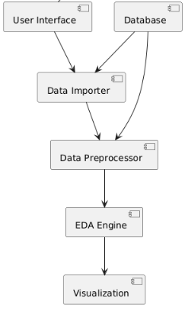

Fig.1: Block Diagram of the Proposed System.

**4.2 Data Preprocessing**

Data pre-processing is a process of preparing the raw data and making it suitable for a data analysis. It is the first and crucial step while generating insights form data.When creating a Data Analysis project, it is not always a case that we come across the clean and formatted data. And while doing any operation with data, it is mandatory to clean it and put in a formatted way. So, for this, we use data pre-processing task.A real-world data generally contains noises, missing values, and maybe in an unusable format which cannot be directly used for Data analysis. Data pre-processing is required tasks for cleaning the data and making it suitable for analysing to get more valuable Insights.

* Getting the dataset
* Importing libraries
* Importing datasets
* Finding Missing Data
* Encoding Categorical Data

**Importing Libraries:** To perform data preprocessing using Python, we need to import some predefined Python libraries. These libraries are used to perform some specific jobs. There are three specific libraries that we will use for data preprocessing, which are:

Numpy: Numpy Python library is used for including any type of mathematical operation in the code. It is the fundamental package for scientific calculation in Python. It also supports to add large, multidimensional arrays and matrices. So, in Python, we can import it as:

import numpy as np

Here we have used nm, which is a short name for Numpy, and it will be used in the whole program.

Matplotlib: The second library is matplotlib, which is a Python 2D plotting library, and with this library, we need to import a sub-library pyplot. This library is used to plot any type of charts in Python for the code. It will be imported as below:

import matplotlib.pyplot as plt

Here we have used mpt as a short name for this library.

Pandas: The last library is the Pandas library, which is one of the most famous Python libraries and used for importing and managing the datasets. It is an open-source data manipulation and analysis library. Here, we have used pd as a short name for this library. Consider the below image:

**Cleaning and Handling Missing Values**

The first step in data preprocessing involves cleaning the dataset to address any inconsistencies or errors. This includes identifying and handling missing values in the dataset. Missing data can arise due to various reasons such as data collection errors or incomplete records. Techniques such as imputation (replacing missing values with estimated values based on other data points) or deletion of incomplete records may be employed to ensure data completeness without compromising the integrity of the analysis.

**4.3 Exploratory Data Analysis (EDA)**

Exploratory Data Analysis (EDA) is an approach to analyzing datasets to summarize their main characteristics, often using visual methods. EDA is a crucial initial step in data analysis that allows data scientists and analysts to understand the underlying structure of the data, uncover patterns, detect anomalies, and check assumptions. The primary goal of EDA is to gain insights into the dataset and guide further analysis by visualizing data distributions, relationships between variables, and overall data quality.

EDA involves various techniques, including statistical summaries and graphical representations. By using these techniques, analysts can reveal hidden insights that may not be apparent through simple descriptive statistics alone. Visualization techniques in EDA are particularly useful for identifying trends, correlations, and outliers, which can help in formulating hypotheses and making informed decisions.

**4.4 EDA Plots**

**Bar Plot**

The bar plot is used to visualize the average temperature by country. This plot provides a clear comparison of the mean temperature across different countries. Each bar represents a country, and its height corresponds to the average temperature recorded. This type of plot is useful for identifying which countries experience higher or lower average temperatures, and it helps in comparing the climatic conditions of different regions at a glance.

**Box Plot**

The box plot for temperature by country displays the distribution of temperature values for each country. This visualization shows the median, quartiles, and potential outliers within the temperature data. The central box represents the interquartile range (IQR), with the line inside the box indicating the median temperature. The whiskers extend to the smallest and largest values within 1.5 times the IQR from the quartiles, while points outside this range are considered outliers. This plot is instrumental in understanding the spread and variability of temperatures across countries and identifying any anomalies or extreme values.

**Count Plot**

Count plots are used to visualize the frequency of occurrences for categorical variables. The count plot for location shows how many observations are recorded for each location in the dataset. Each bar represents a location, with the height indicating the number of records. Similarly, the count plot for country displays the frequency of observations for each country. These plots are useful for understanding the distribution of data across different locations and countries, which can reveal imbalances or biases in the dataset.

**Scatter Plot**

The scatter plot of temperature versus CO2 emissions explores the relationship between these two variables. Each point on the plot represents a data record with its temperature and CO2 emissions values. This visualization helps in identifying any correlation or trend between temperature and CO2 emissions. For example, a positive correlation might indicate that higher CO2 emissions are associated with higher temperatures, providing insights into the impact of greenhouse gases on climate change.

**Autocorrelation Plot**

The autocorrelation plot for temperature examines how temperature values are correlated with themselves over different time lags. This plot helps in understanding the temporal dependencies in the temperature data. A strong autocorrelation at a particular lag indicates that temperature values are not independent over time, which can reveal cyclical patterns or trends in the temperature data.

**Heatmap**

The heatmap of the correlation matrix visualizes the relationships between multiple climate variables, such as temperature, CO2 emissions, sea level rise, precipitation, humidity, and wind speed. Each cell in the heatmap represents the correlation coefficient between two variables, with colors indicating the strength and direction of the correlation. This visualization is valuable for identifying which variables are strongly correlated with each other, facilitating a deeper understanding of the interactions within the climate data.

**Histogram**

The histogram of temperature shows the distribution of temperature values across the dataset. It groups temperature values into bins and displays the frequency of records within each bin. This plot is useful for understanding the overall distribution of temperature, such as whether it follows a normal distribution, has skewness, or displays any unusual patterns.

**Violin Plot**

The violin plot for temperature by country combines aspects of box plots and density plots. It shows the distribution of temperature values across different countries, with each "violin" representing the density of temperature values. The width of each violin at different temperature levels indicates the density of data points, while the central box displays the IQR and median. This plot provides a more detailed view of temperature distributions compared to box plots and highlights differences between countries.

**Pair Plot**

The pair plot visualizes relationships between multiple numerical features in the dataset, including temperature, CO2 emissions, sea level rise, precipitation, humidity, and wind speed. It displays scatter plots for each pair of variables, along with histograms of individual variables along the diagonal. This comprehensive plot helps in exploring pairwise correlations and detecting patterns or clusters in the data.

**Line Plot**

The line plot of temperature over time tracks changes in temperature across different dates. Each point represents a temperature reading for a specific date, and the line connects these points to show the trend over time. This visualization is useful for identifying temporal trends, seasonal variations, or long-term changes in temperature.

**Joint Plot**

The joint plot of temperature and CO2 emissions combines scatter plots with histograms of each variable. It displays the relationship between temperature and CO2 emissions, along with the distribution of each variable on the margins. This plot provides a detailed view of how temperature and CO2 emissions interact and helps in assessing the strength and nature of their relationship.

**CHAPTER 5**

**UML DIAGRAMS**

UML stands for Unified Modeling Language. UML is a standardized general-purpose modeling language in the field of object-oriented software engineering. The standard is managed, and was created by, the Object Management Group. The goal is for UML to become a common language for creating models of object-oriented computer software. In its current form UML is comprised of two major components: a Meta-model and a notation. In the future, some form of method or process may also be added to; or associated with, UML.

The Unified Modeling Language is a standard language for specifying, Visualization, Constructing and documenting the artifacts of software system, as well as for business modeling and other non-software systems. The UML represents a collection of best engineering practices that have proven successful in the modeling of large and complex systems. The UML is a very important part of developing objects-oriented software and the software development process. The UML uses mostly graphical notations to express the design of software projects.

**GOALS:** The Primary goals in the design of the UML are as follows:

* Provide users a ready-to-use, expressive visual modeling Language so that they can develop and exchange meaningful models.
* Provide extendibility and specialization mechanisms to extend the core concepts.
* Be independent of particular programming languages and development process.
* Provide a formal basis for understanding the modeling language.
* Encourage the growth of OO tools market.
* Support higher level development concepts such as collaborations, frameworks, patterns and components.
* Integrate best practices.

**Class diagram**

The class diagram is used to refine the use case diagram and define a detailed design of the system. The class diagram classifies the actors defined in the use case diagram into a set of interrelated classes. The relationship or association between the classes can be either an "is-a" or "has-a" relationship. Each class in the class diagram was capable of providing certain functionalities. These functionalities provided by the class are termed "methods" of the class. Apart from this, each class may have certain "attributes" that uniquely identify the class.

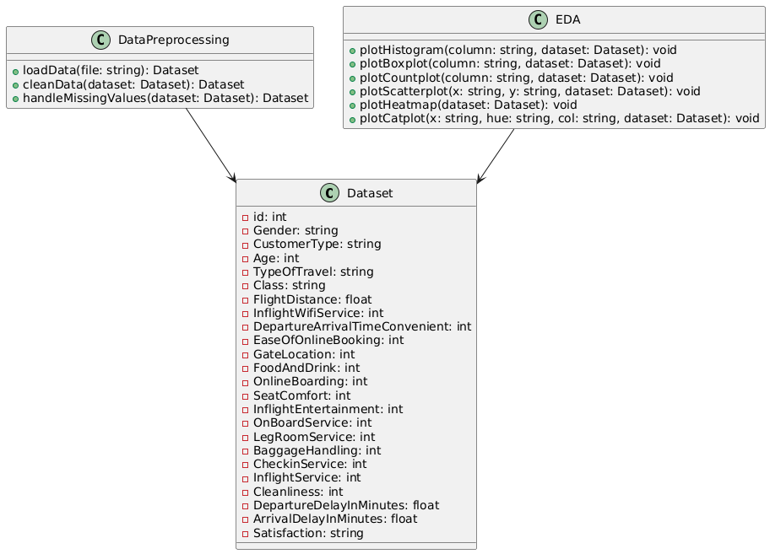

Figure-5.1: Class Diagram

**Sequence Diagram**

A sequence diagram in Unified Modeling Language (UML) is a kind of interaction diagram that shows how processes operate with one another and in what order. It is a construct of a Message Sequence Chart. A sequence diagram shows, as parallel vertical lines (“lifelines”), different processes or objects that live simultaneously, and as horizontal arrows, the messages exchanged between them, in the order in which they occur. This allows the specification of simple runtime scenarios in a graphical manner.

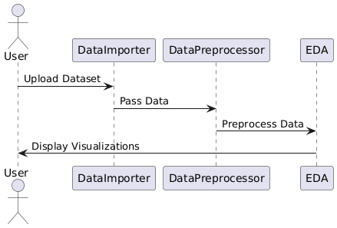

Figure-5.2: Sequence Diagram.

**Data flow diagram**

A data flow diagram (DFD) is a graphical representation of how data moves within an information system. It is a modeling technique used in system analysis and design to illustrate the flow of data between various processes, data stores, data sources, and data destinations within a system or between systems. Data flow diagrams are often used to depict the structure and behavior of a system, emphasizing the flow of data and the transformations it undergoes as it moves through the system.

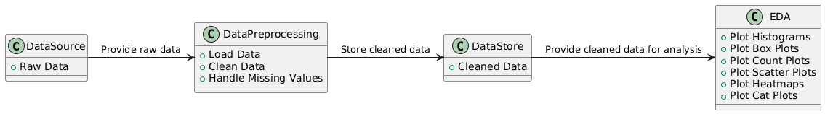

Figure-5.3: Dataflow Diagram

**Activity diagram**

Activity diagrams are graphical representations of Workflows of stepwise activities and actions with support for choice, iteration, and concurrency. In the Unified Modeling Language, activity diagrams can be used to describe the business and operational step-by-step workflows of components in a system. An activity diagram shows the overall flow of control.

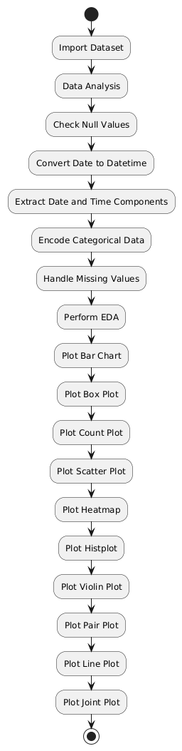

Figure-5.4: Activity Diagram

**Component diagram:** Component diagram describes the organization and wiring of the physical components in a system.

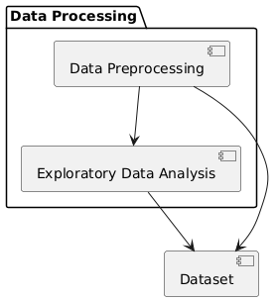

Figure-5.5: Component Diagram

**Use Case diagram:**

A use case diagram in the Unified Modeling Language (UML) is a type of behavioral diagram defined by and created from a Use-case analysis. Its purpose is to present a graphical overview of the functionality provided by a system in terms of actors, their goals (represented as use cases), and any dependencies between those use cases. The main purpose of a use case diagram is to show what system functions are performed for which actor. Roles of the actors in the system can be depicted.

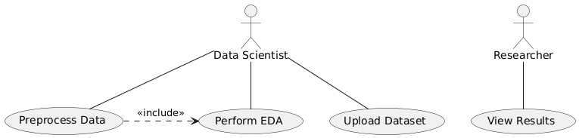

Figure-5.6: Use Case Diagram

**Deployment Diagram:**

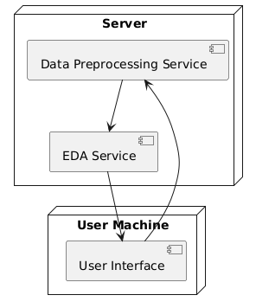

Figure-5.7: Deployment Diagram.

**CHAPTER 6**

**SOFTWARE ENVIRONMENT**

**What is Python?**

Below are some facts about Python.

* Python is currently the most widely used multi-purpose, high-level programming language.
* Python allows programming in Object-Oriented and Procedural paradigms. Python programs generally are smaller than other programming languages like Java.
* Programmers have to type relatively less and indentation requirement of the language, makes them readable all the time.
* Python language is being used by almost all tech-giant companies like – Google, Amazon, Facebook, Instagram, Dropbox, Uber… etc.

The biggest strength of Python is huge collection of standard library which can be used for the following –

* Machine Learning
* GUI Applications (like Kivy, Tkinter, PyQt etc. )
* Web frameworks like Django (used by YouTube, Instagram, Dropbox)
* Image processing (like Opencv, Pillow)
* Web scraping (like Scrapy, BeautifulSoup, Selenium)
* Test frameworks
* Multimedia

**Advantages of Python**

Let’s see how Python dominates over other languages.

1. **Extensive Libraries**

Python downloads with an extensive library and it contain code for various purposes like regular expressions, documentation-generation, unit-testing, web browsers, threading, databases, CGI, email, image manipulation, and more. So, we don’t have to write the complete code for that manually.

**2. Extensible**

As we have seen earlier, Python can be extended to other languages. You can write some of your code in languages like C++ or C. This comes in handy, especially in projects.

**3. Embeddable**

Complimentary to extensibility, Python is embeddable as well. You can put your Python code in your source code of a different language, like C++. This lets us add scripting capabilities to our code in the other language.

**4. Improved Productivity**

The language’s simplicity and extensive libraries render programmers more productive than languages like Java and C++ do. Also, the fact that you need to write less and get more things done.

**5. IOT Opportunities**

Since Python forms the basis of new platforms like Raspberry Pi, it finds the future bright for the Internet Of Things. This is a way to connect the language with the real world.

**6. Simple and Easy**

When working with Java, you may have to create a class to print ‘Hello World’. But in Python, just a print statement will do. It is also quite easy to learn, understand, and code. This is why when people pick up Python, they have a hard time adjusting to other more verbose languages like Java.

**7. Readable**

Because it is not such a verbose language, reading Python is much like reading English. This is the reason why it is so easy to learn, understand, and code. It also does not need curly braces to define blocks, and indentation is mandatory. This further aids the readability of the code.

**8. Object-Oriented**

This language supports both the procedural and object-oriented programming paradigms. While functions help us with code reusability, classes and objects let us model the real world. A class allows the encapsulation of data and functions into one.

**9. Free and Open-Source**

Like we said earlier, Python is freely available. But not only can you download Python for free, but you can also download its source code, make changes to it, and even distribute it. It downloads with an extensive collection of libraries to help you with your tasks.

**10. Portable**

When you code your project in a language like C++, you may need to make some changes to it if you want to run it on another platform. But it isn’t the same with Python. Here, you need to code only once, and you can run it anywhere. This is called Write Once Run Anywhere (WORA). However, you need to be careful enough not to include any system-dependent features.

1. **Interpreted**

Lastly, we will say that it is an interpreted language. Since statements are executed one by one, debugging is easier than in compiled languages.

Any doubts till now in the advantages of Python? Mention in the comment section.

**Advantages of Python Over Other Languages**

1. **Less Coding**

Almost all of the tasks done in Python requires less coding when the same task is done in other languages. Python also has an awesome standard library support, so you don’t have to search for any third-party libraries to get your job done. This is the reason that many people suggest learning Python to beginners.

**2. Affordable**

Python is free therefore individuals, small companies or big organizations can leverage the free available resources to build applications. Python is popular and widely used so it gives you better community support.

The 2019 Github annual survey showed us that Python has overtaken Java in the most popular programming language category.

**3. Python is for Everyone**

Python code can run on any machine whether it is Linux, Mac or Windows. Programmers need to learn different languages for different jobs but with Python, you can professionally build web apps, perform data analysis and machine learning, automate things, do web scraping and also build games and powerful visualizations. It is an all-rounder programming language.

**Disadvantages of Python**

So far, we’ve seen why Python is a great choice for your project. But if you choose it, you should be aware of its consequences as well. Let’s now see the downsides of choosing Python over another language.

1. **Speed Limitations**

We have seen that Python code is executed line by line. But since Python is interpreted, it often results in slow execution. This, however, isn’t a problem unless speed is a focal point for the project. In other words, unless high speed is a requirement, the benefits offered by Python are enough to distract us from its speed limitations.

**2. Weak in Mobile Computing and Browsers**

While it serves as an excellent server-side language, Python is much rarely seen on the client-side. Besides that, it is rarely ever used to implement smartphone-based applications. One such application is called Carbonnelle.

The reason it is not so famous despite the existence of Brython is that it isn’t that secure.

**3. Design Restrictions**

As you know, Python is dynamically typed. This means that you don’t need to declare the type of variable while writing the code. It uses duck-typing. But wait, what’s that? Well, it just means that if it looks like a duck, it must be a duck. While this is easy on the programmers during coding, it can raise run-time errors.

**4. Underdeveloped Database Access Layers**

Compared to more widely used technologies like JDBC (Java DataBase Connectivity) and ODBC (Open DataBase Connectivity), Python’s database access layers are a bit underdeveloped. Consequently, it is less often applied in huge enterprises.

**5. Simple**

No, we’re not kidding. Python’s simplicity can indeed be a problem. Take my example. I don’t do Java, I’m more of a Python person. To me, its syntax is so simple that the verbosity of Java code seems unnecessary.

This was all about the Advantages and Disadvantages of Python Programming Language.

**Modules Used in Project**

**NumPy**

NumPy is a general-purpose array-processing package. It provides a high-performance multidimensional array object, and tools for working with these arrays.

It is the fundamental package for scientific computing with Python. It contains various features including these important ones:

* A powerful N-dimensional array object
* Sophisticated (broadcasting) functions
* Tools for integrating C/C++ and Fortran code
* Useful linear algebra, Fourier transform, and random number capabilities

Besides its obvious scientific uses, NumPy can also be used as an efficient multi-dimensional container of generic data. Arbitrary datatypes can be defined using NumPy which allows NumPy to seamlessly and speedily integrate with a wide variety of databases.

**Pandas**

Pandas is an open-source Python Library providing high-performance data manipulation and analysis tool using its powerful data structures. Python was majorly used for data munging and preparation. It had very little contribution towards data analysis. Pandas solved this problem. Using Pandas, we can accomplish five typical steps in the processing and analysis of data, regardless of the origin of data load, prepare, manipulate, model, and analyze. Python with Pandas is used in a wide range of fields including academic and commercial domains including finance, economics, Statistics, analytics, etc.

**Matplotlib**

Matplotlib is a Python 2D plotting library which produces publication quality figures in a variety of hardcopy formats and interactive environments across platforms. Matplotlib can be used in Python scripts, the Python and Ipython shells, the Jupyter Notebook, web application servers, and four graphical user interface toolkits. Matplotlib tries to make easy things easy and hard things possible. You can generate plots, histograms, power spectra, bar charts, error charts, scatter plots, etc., with just a few lines of code. For examples, see the sample plots and thumbnail gallery.

For simple plotting the pyplot module provides a MATLAB-like interface, particularly when combined with Ipython. For the power user, you have full control of line styles, font properties, axes properties, etc, via an object oriented interface or via a set of functions familiar to MATLAB users.

**Scikit – learn**

Scikit-learn provides a range of supervised and unsupervised learning algorithms via a consistent interface in Python. It is licensed under a permissive simplified BSD license and is distributed under many Linux distributions, encouraging academic and commercial use. Python

**Install Python Step-by-Step in Windows and Mac**

Python a versatile programming language doesn’t come pre-installed on your computer devices. Python was first released in the year 1991 and until today it is a very popular high-level programming language. Its style philosophy emphasizes code readability with its notable use of great whitespace.

The object-oriented approach and language construct provided by Python enables programmers to write both clear and logical code for projects. This software does not come pre-packaged with Windows.

**How to Install Python on Windows and Mac**

There have been several updates in the Python version over the years. The question is how to install Python? It might be confusing for the beginner who is willing to start learning Python but this tutorial will solve your query. The latest or the newest version of Python is version 3.7.4 or in other words, it is Python 3.

Note: The python version 3.7.4 cannot be used on Windows XP or earlier devices.

Before you start with the installation process of Python. First, you need to know about your System Requirements. Based on your system type i.e. operating system and based processor, you must download the python version. My system type is a Windows 64-bit operating system. So the steps below are to install python version 3.7.4 on Windows 7 device or to install Python 3. Download the Python Cheatsheet here.The steps on how to install Python on Windows 10, 8 and 7 are divided into 4 parts to help understand better.

**Download the Correct version into the system**

Step 1: Go to the official site to download and install python using Google Chrome or any other web browser. OR Click on the following link: <https://www>.python.org

Now, check for the latest and the correct version for your operating system.

Step 2: Click on the Download Tab.

Step 3: You can either select the Download Python for windows 3.7.4 button in Yellow Color or you can scroll further down and click on download with respective to their version. Here, we are downloading the most recent python version for windows 3.7.4

Step 4: Scroll down the page until you find the Files option.

Step 5: Here you see a different version of python along with the operating system.

* To download Windows 32-bit python, you can select any one from the three options: Windows x86 embeddable zip file, Windows x86 executable installer or Windows x86 web-based installer.
* To download Windows 64-bit python, you can select any one from the three options: Windows x86-64 embeddable zip file, Windows x86-64 executable installer or Windows x86-64 web-based installer.

Here we will install Windows x86-64 web-based installer. Here your first part regarding which version of python is to be downloaded is completed. Now we move ahead with the second part in installing python i.e. Installation

Note: To know the changes or updates that are made in the version you can click on the Release Note Option.

**Installation of Python**

Step 1: Go to Download and Open the downloaded python version to carry out the installation process.

Step 2: Before you click on Install Now, Make sure to put a tick on Add Python 3.7 to PATH.

Step 3: Click on Install NOW After the installation is successful. Click on Close.

With these above three steps on python installation, you have successfully and correctly installed Python. Now is the time to verify the installation.

Note: The installation process might take a couple of minutes.

**Verify the Python Installation**

Step 1: Click on Start

Step 2: In the Windows Run Command, type “cmd”.

Step 3: Open the Command prompt option.

Step 4: Let us test whether the python is correctly installed. Type python –V and press Enter.

Step 5: You will get the answer as 3.7.4

Note: If you have any of the earlier versions of Python already installed. You must first uninstall the earlier version and then install the new one.

**Check how the Python IDLE works**

Step 1: Click on Start

Step 2: In the Windows Run command, type “python idle”.

Step 3: Click on IDLE (Python 3.7 64-bit) and launch the program

Step 4: To go ahead with working in IDLE you must first save the file. Click on File > Click on Save

Step 5: Name the file and save as type should be Python files. Click on SAVE. Here I have named the files as Hey World.

Step 6: Now for e.g. enter print (“Hey World”) and Press Enter.

You will see that the command given is launched. With this, we end our tutorial on how to install Python. You have learned how to download python for windows into your respective operating system.

Note: Unlike Java, Python does not need semicolons at the end of the statements otherwise it won’t work.

**CHAPTER 7**

**FUNCTIONAL REQUIREMENTS**

**Output Design**

Outputs from computer systems are required primarily to communicate the results of processing to users. They are also used to provides a permanent copy of the results for later consultation. The various types of outputs in general are:

* External Outputs, whose destination is outside the organization
* Internal Outputs whose destination is within organization and they are the
* User’s main interface with the computer.
* Operational outputs whose use is purely within the computer department.
* Interface outputs, which involve the user in communicating directly.

**Output Definition**

The outputs should be defined in terms of the following points:

* Type of the output
* Content of the output
* Format of the output
* Location of the output
* Frequency of the output
* Volume of the output
* Sequence of the output

It is not always desirable to print or display data as it is held on a computer. It should be decided as which form of the output is the most suitable.

**Input Design**

Input design is a part of overall system design. The main objective during the input design is as given below:

* To produce a cost-effective method of input.
* To achieve the highest possible level of accuracy.
* To ensure that the input is acceptable and understood by the user.

**Input Stages**

The main input stages can be listed as below:

* Data recording
* Data transcription
* Data conversion
* Data verification
* Data control
* Data transmission
* Data validation
* Data correction

**Input Types**

It is necessary to determine the various types of inputs. Inputs can be categorized as follows:

* External inputs, which are prime inputs for the system.
* Internal inputs, which are user communications with the system.
* Operational, which are computer department’s communications to the system?
* Interactive, which are inputs entered during a dialogue.

**Input Media**

At this stage choice has to be made about the input media. To conclude about the input media consideration has to be given to;

* Type of input
* Flexibility of format
* Speed
* Accuracy
* Verification methods
* Rejection rates
* Ease of correction
* Storage and handling requirements
* Security
* Easy to use
* Portability

Keeping in view the above description of the input types and input media, it can be said that most of the inputs are of the form of internal and interactive. As

Input data is to be the directly keyed in by the user, the keyboard can be considered to be the most suitable input device.

**Error Avoidance**

At this stage care is to be taken to ensure that input data remains accurate form the stage at which it is recorded up to the stage in which the data is accepted by the system. This can be achieved only by means of careful control each time the data is handled.

**Error Detection**

Even though every effort is make to avoid the occurrence of errors, still a small proportion of errors is always likely to occur, these types of errors can be discovered by using validations to check the input data.

**Data Validation**

Procedures are designed to detect errors in data at a lower level of detail. Data validations have been included in the system in almost every area where there is a possibility for the user to commit errors. The system will not accept invalid data. Whenever an invalid data is keyed in, the system immediately prompts the user and the user has to again key in the data and the system will accept the data only if the data is correct. Validations have been included where necessary.

The system is designed to be a user friendly one. In other words the system has been designed to communicate effectively with the user. The system has been designed with popup menus.

**User Interface Design**

It is essential to consult the system users and discuss their needs while designing the user interface:

**User Interface Systems Can Be Broadly Clasified As:**

* User initiated interface the user is in charge, controlling the progress of the user/computer dialogue. In the computer-initiated interface, the computer selects the next stage in the interaction.
* Computer initiated interfaces

In the computer-initiated interfaces the computer guides the progress of the user/computer dialogue. Information is displayed and the user response of the computer takes action or displays further information.

**User Initiated Interfaces**

User initiated interfaces fall into two approximate classes:

* Command driven interfaces: In this type of interface the user inputs commands or queries which are interpreted by the computer.
* Forms oriented interface: The user calls up an image of the form to his/her screen and fills in the form. The forms-oriented interface is chosen because it is the best choice.

**Computer-Initiated Interfaces**

The following computer – initiated interfaces were used:

* The menu system for the user is presented with a list of alternatives and the user chooses one; of alternatives.
* Questions – answer type dialog system where the computer asks question and takes action based on the basis of the users reply.

Right from the start the system is going to be menu driven, the opening menu displays the available options. Choosing one option gives another popup menu with more options. In this way every option leads the users to data entry form where the user can key in the data.

**Error Message Design**

The design of error messages is an important part of the user interface design. As user is bound to commit some errors or other while designing a system the system should be designed to be helpful by providing the user with information regarding the error he/she has committed.

This application must be able to produce output at different modules for different inputs.

**Performance Requirements**

Performance is measured in terms of the output provided by the application. Requirement specification plays an important part in the analysis of a system. Only when the requirement specifications are properly given, it is possible to design a system, which will fit into required environment. It rests largely in the part of the users of the existing system to give the requirement specifications because they are the people who finally use the system. This is because the requirements have to be known during the initial stages so that the system can be designed according to those requirements. It is very difficult to change the system once it has been designed and on the other hand designing a system, which does not cater to the requirements of the user, is of no use.

The requirement specification for any system can be broadly stated as given below:

* The system should be able to interface with the existing system
* The system should be accurate
* The system should be better than the existing system
* The existing system is completely dependent on the user to perform all the duties.

**CHAPTER 9**

**SOURCE CODE**

# CLIMATE CHANGE INSIGHTS: GRAPHICAL DATA REPRESENTATION AND ANALYSIS

## Importing Libraries

import numpy as np

import pandas as pd

import seaborn as sns

import matplotlib.pyplot as plt

import missingno as msno

import folium

from sklearn.preprocessing import LabelEncoder

## Importing Dataset

df = pd.read_csv(r'climate_change_data.csv')

df.head()

## Data Analysis

df.info()

df.nunique()

df.describe().T

df.isnull().sum()

# Convert Date column to datetime format

df['Date'] = pd.to_datetime(df['Date'])

# Extract date and time components

df['Year'] = df['Date'].dt.year

df['Month'] = df['Date'].dt.month

df['Day'] = df['Date'].dt.day

df['Hour'] = df['Date'].dt.hour

df['Minute'] = df['Date'].dt.minute

df['Second'] = df['Date'].dt.second

# Drop original Date column if no longer needed

df = df.drop(columns=['Date'])

print(df)

label_encoder = LabelEncoder()

df['Location'] = label_encoder.fit_transform(df['Location'])

df['Country'] = label_encoder.fit_transform(df['Country'])

df

## Data Cleaning

df.info()

df.describe()

## EDA (Exploratory Data Analysis)

# Bar Plot

# Bar Plot for Average Temperature by Country

plt.figure(figsize=(12, 6))

sns.barplot(x='Country', y='Temperature', data=df, estimator='mean')

plt.title('Average Temperature by Country')

plt.xticks(rotation=90)

plt.show()

# Box Plot

# Box Plot for Temperature by Country

plt.figure(figsize=(12, 6))

sns.boxplot(x='Country', y='Temperature', data=df)

plt.title('Temperature Box Plot by Country')

plt.xticks(rotation=90)

plt.show()

# Count Plot

# Count Plot for Location

plt.figure(figsize=(10, 6))

sns.countplot(x='Location', data=df)

plt.title('Count of Locations')

plt.xticks(rotation=90)

plt.show()

# Count Plot for Country

plt.figure(figsize=(10, 6))

sns.countplaot(x='Country', data=df)

plt.title('Count of Countries')

plt.xticks(rotation=90)

plt.show()

# Scatter Plot

# Scatter Plot for Temperature vs CO2 Emissions

plt.figure(figsize=(10, 6))

sns.scatterplot(x='Temperature', y='CO2 Emissions', data=df)

plt.title('Temperature vs CO2 Emissions')

plt.show()

# Autocorrelation Plot

from pandas.plotting import autocorrelation_plot

# Autocorrelation Plot for Temperature

plt.figure(figsize=(10, 6))

autocorrelation_plot(df['Temperature'])

plt.title('Autocorrelation Plot of Temperature')

plt.show()

# Heatmap

# Heatmap for correlation matrix

plt.figure(figsize=(12, 8))

correlation_matrix = df[['Temperature', 'CO2 Emissions', 'Sea Level Rise', 'Precipitation', 'Humidity', 'Wind Speed']].corr()

sns.heatmap(correlation_matrix, annot=True, cmap='coolwarm', fmt='.2f')

plt.title('Correlation Heatmap')

plt.show()

# histplot

# Histogram for Temperature

plt.figure(figsize=(10, 6))

sns.histplot(df['Temperature'], bins=30, kde=True)

plt.title('Distribution of Temperature')

plt.show()

# Violin Plot

# Violin Plot for Temperature by Country

plt.figure(figsize=(12, 6))

sns.violinplot(x='Country', y='Temperature', data=df)

plt.title('Temperature Distribution by Country')

plt.xticks(rotation=90)

plt.show()

# Pair Plot

# Pair Plot for numerical features

sns.pairplot(df[['Temperature', 'CO2 Emissions', 'Sea Level Rise', 'Precipitation', 'Humidity', 'Wind Speed']])

plt.title('Pair Plot of Numerical Features')

plt.show()

# Line Plot for Temperature over Time

plt.figure(figsize=(12, 6))

df['Date'] = pd.to_datetime(df[['Year', 'Month', 'Day']])

sns.lineplot(x='Date', y='Temperature', data=df)

plt.title('Temperature Trend Over Time')

plt.show()

# Joint Plot

# Joint Plot for Temperature and CO2 Emissions

sns.jointplot(x='Temperature', y='CO2 Emissions', data=df, kind='scatter')

plt.title('Joint Plot of Temperature and CO2 Emissions')

plt.show()

**CHAPTER 10**

**RESULTS AND DISCUSSION**

**10.1 Implementation Description**

The research provides a structured approach to analyzing climate change data through a series of well-defined steps, leveraging data preprocessing, exploration, and visualization techniques to derive insights from the dataset. The implementation begins with essential setup and data handling processes and progresses through exploratory data analysis (EDA) to reveal underlying trends and patterns.

**Initial Setup and Data Import**

The project intilizes by importing a suite of Python libraries crucial for data manipulation and visualization. Libraries such as NumPy and Pandas are used for handling data operations, while Seaborn and Matplotlib are employed for creating visualizations. Missingno is included to assist in visualizing missing values, and Folium, although not directly used in the provided code, is often used for geographical plotting. The dataset is loaded into a Pandas DataFrame from a CSV file, establishing the foundation for subsequent analysis. The initial inspection of the dataset is performed using functions like head(), info(), nunique(), and describe().T, providing a snapshot of the data's structure, uniqueness, and summary statistics.

**Data Cleaning and Transformation**

Data cleaning is a critical step that follows the initial inspection. The Date column is converted to a datetime format to facilitate time-based operations. Extracting individual components such as year, month, day, hour, minute, and second from the datetime object allows for detailed temporal analysis. The original Date column is then removed as it is no longer needed. Categorical columns, specifically Location and Country, are transformed into numerical values using label encoding, which simplifies these variables for further analysis and visualization. This transformation ensures that all data is in a consistent format, ready for the exploratory phase.

**Exploratory Data Analysis (EDA)**

The exploratory data analysis phase involves a variety of plots to uncover insights from the dataset. The analysis begins with a bar plot showing the average temperature by country. This visualization helps in comparing the mean temperatures across different countries, highlighting regional climatic differences. A box plot is used next to visualize the distribution of temperature values for each country, providing insights into temperature variability and identifying any outliers.

Count plots follow, revealing the frequency of data points for different locations and countries. These plots are instrumental in understanding the distribution of data and identifying any potential imbalances. The scatter plot of temperature versus CO2 emissions investigates the relationship between these two variables, aiming to identify any correlations.

An autocorrelation plot is generated to examine the temporal dependencies in temperature data. This plot helps in detecting patterns or trends over time. The heatmap of the correlation matrix provides a comprehensive view of how different climate variables relate to each other, highlighting strong correlations that could inform further analysis.

The histogram for temperature distribution helps in understanding how temperature values are spread across the dataset, while the violin plot offers a detailed view of temperature distributions by country, combining aspects of density and variability. A pair plot is created to explore the relationships between multiple numerical features, offering a broad view of how different climate variables interact.

A line plot tracks the trend of temperature over time, revealing any long-term changes or seasonal patterns. Finally, the joint plot of temperature and CO2 emissions provides a combined view of their relationship and individual distributions, offering insights into their interaction.

**10. 2 Dataset Description**

Here's a concise description of each column in the dataset:

* **Date**: The date and time when the climate data was recorded. It includes information down to the second, providing a precise temporal context for each observation.
* **Location**: The specific geographical location where the climate data was collected, represented as a numerical identifier after encoding.
* **Country**: The country where the data collection site is located, transformed into a numerical identifier to facilitate analysis.
* **Temperature**: The recorded temperature at the specified location, expressed in degrees Celsius, reflecting the climate conditions.
* **CO2 Emissions**: The amount of CO2 emissions measured at the location, typically in parts per million (ppm), indicating the level of greenhouse gases.
* **Sea Level Rise**: The observed change in sea level, measured in meters, representing the impact of climate change on sea levels.
* **Precipitation**: The amount of precipitation (rain, snow, etc.) recorded, measured in millimeters, indicating the level of rainfall or other forms of precipitation.
* **Humidity**: The relative humidity percentage at the location, indicating the amount of moisture present in the air.
* **Wind Speed**: The speed of wind at the location, measured in meters per second, reflecting the intensity of wind conditions.
* **Year**: The year when the data was recorded, extracted from the Date column, providing a temporal reference.
* **Month**: The month of the year when the data was recorded, derived from the Date column, helping to analyze seasonal variations.
* **Day**: The day of the month when the data was recorded, obtained from the Date column, useful for detailed time-series analysis.
* **Hour**: The hour of the day when the data was recorded, extracted from the Date column, allowing for hourly trend analysis.
* **Minute**: The minute of the hour when the data was recorded, providing a finer temporal resolution for the dataset.
* **Second**: The second of the minute when the data was recorded, giving the most granular time detail for each observation.

**10.3 Results and Description**

Figure 1 displays a sample of the raw climate change dataset. It includes columns such as Location, Country, Temperature, CO2 Emissions, Sea Level Rise, Precipitation, Humidity, Wind Speed, and various date and time components. This sample provides an initial view of the data structure and content, highlighting key metrics related to climate variables.

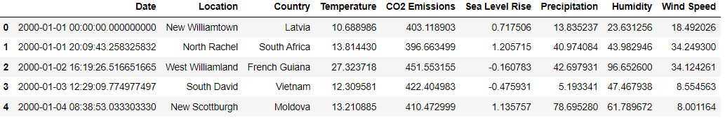

Figure 1: Sample Uploaded Dataset

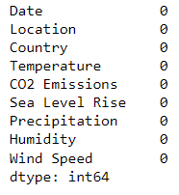

Figure 2: Checking Null Values in the Dataset

Figure 2 visualizes the presence of null values within the dataset. It uses a heatmap to indicate which columns contain missing values and their extent. This plot helps in identifying gaps in the data that may need to be addressed before further analysis.

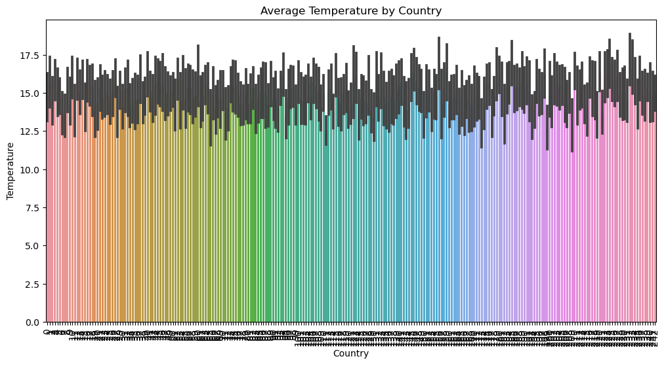

Figure 3: Average Temperature by Country

Figure 3 presents a bar plot showing the average temperature for each country. Each bar represents a country, with its height indicating the mean temperature recorded. This plot provides a comparison of climatic conditions across different countries.

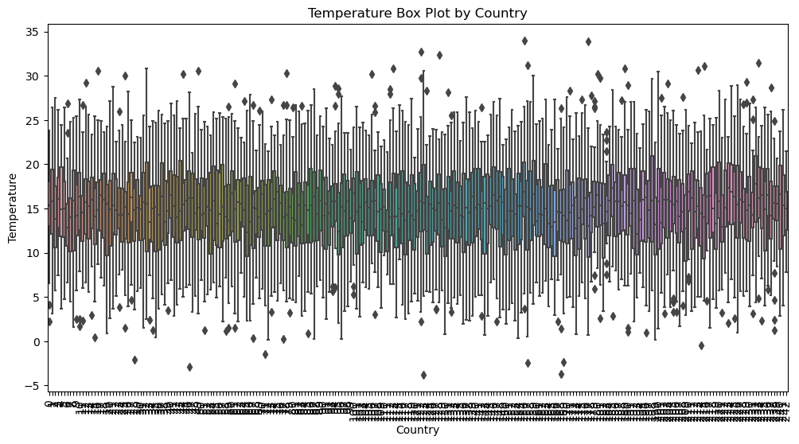

Figure 4: Temperature Box Plot by Country

Figure 4 displays a box plot for temperature values across different countries. This plot shows the distribution of temperatures, including median, quartiles, and outliers for each country. It provides insights into the variability and spread of temperature data.

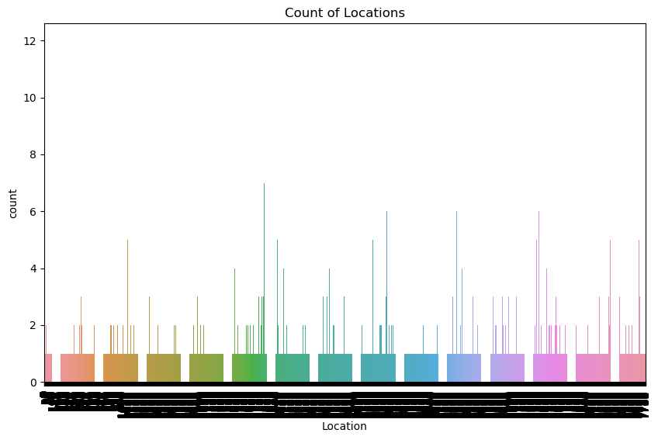

Figure 5: Count of Locations

Figure 5 features a count plot that illustrates the number of data records for each location. Each bar represents a location, and the height of the bar indicates the frequency of observations. This plot helps in understanding the distribution of data across various locations.

Figure 6: Count of Countries

Figure 6 shows a count plot for the number of records by country. Each bar represents a country, and the bar height denotes the count of data entries associated with each country. This plot aids in identifying how data is distributed among different countries.

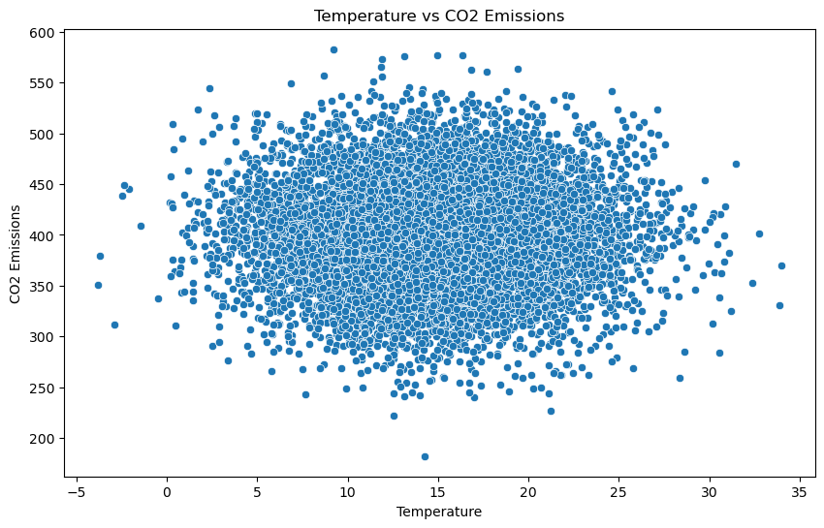

Figure 7: Temperature vs CO2 Emissions

Figure 7 is a scatter plot depicting the relationship between temperature and CO2 emissions. Each point represents an observation, with its position indicating the corresponding temperature and CO2 emission levels. This plot helps in exploring potential correlations between these two variables.

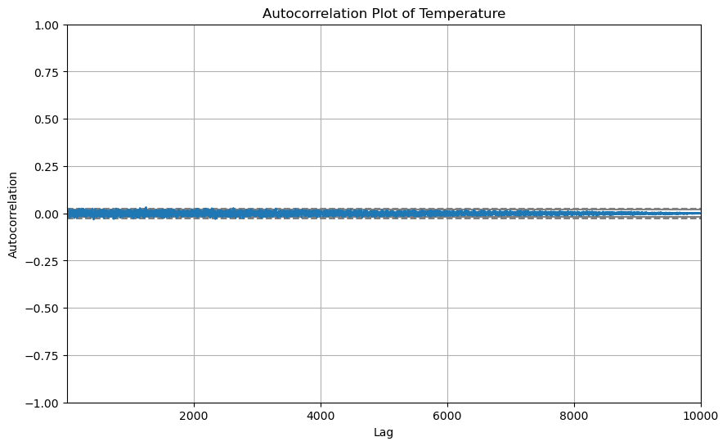

Figure 8: Autocorrelation Plot of Temperature

Figure 8 presents an autocorrelation plot for temperature data. It shows how temperature values are correlated with themselves over different time lags, helping to detect patterns and trends in temperature data over time.

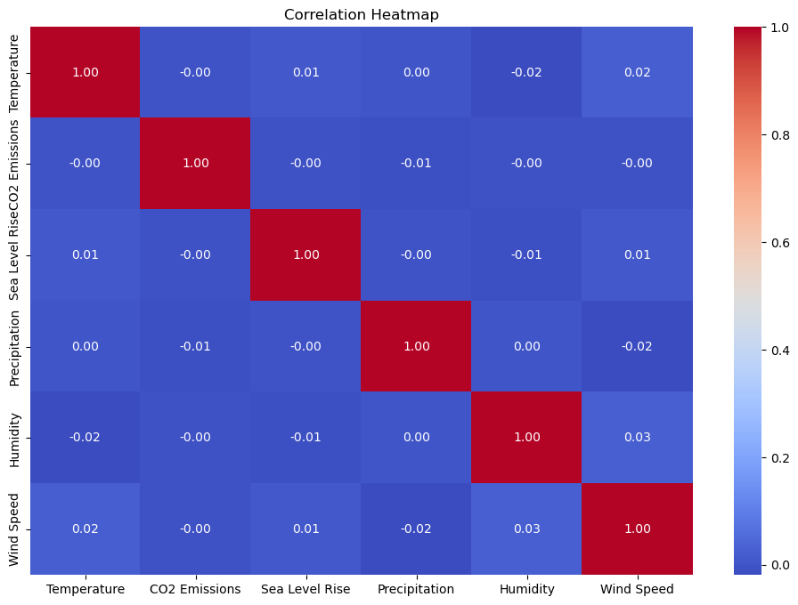

Figure 9: Correlation Heatmap

Figure 9 features a heatmap of the correlation matrix for various climate variables, including temperature, CO2 emissions, sea level rise, precipitation, humidity, and wind speed. This plot highlights the strength and direction of correlations between these variables.

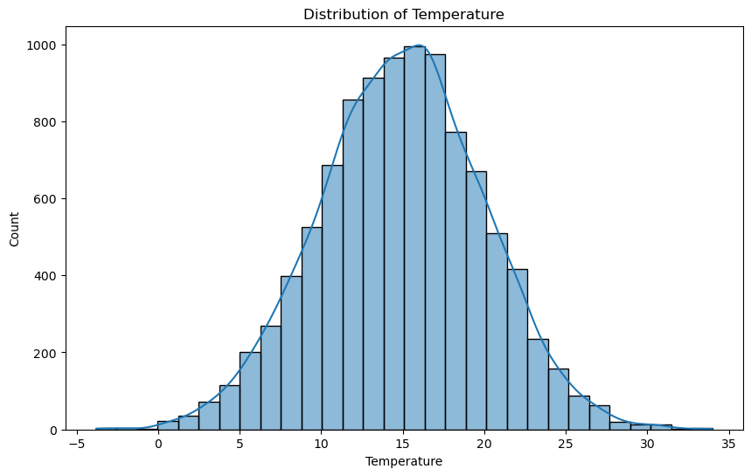

Figure 10: Distribution of Temperature

Figure 10 shows a histogram of temperature values. It displays the frequency distribution of temperature readings across different bins, providing insights into the overall distribution and spread of temperature data.

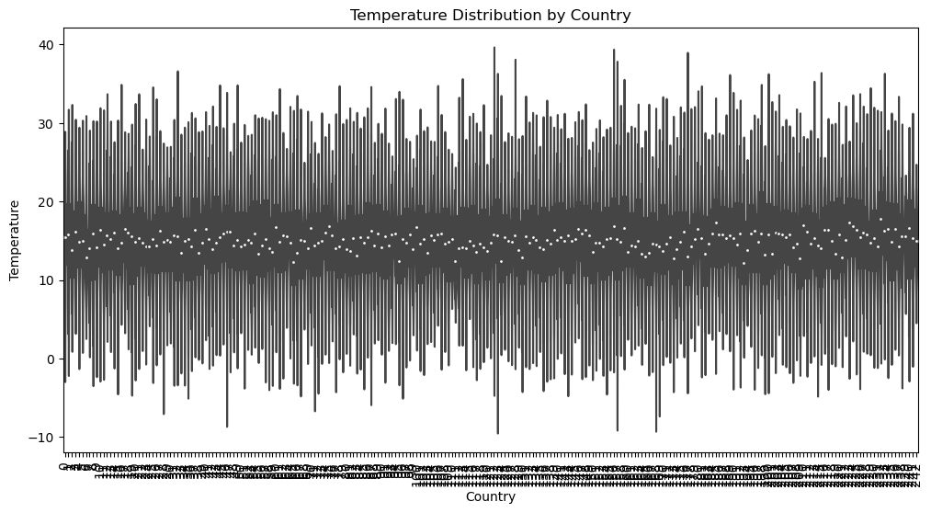

Figure 11: Temperature Distribution by Country

Figure 11 features a violin plot that visualizes the distribution of temperature values across different countries. It combines aspects of density and variability, offering a detailed view of how temperatures are distributed in various countries.

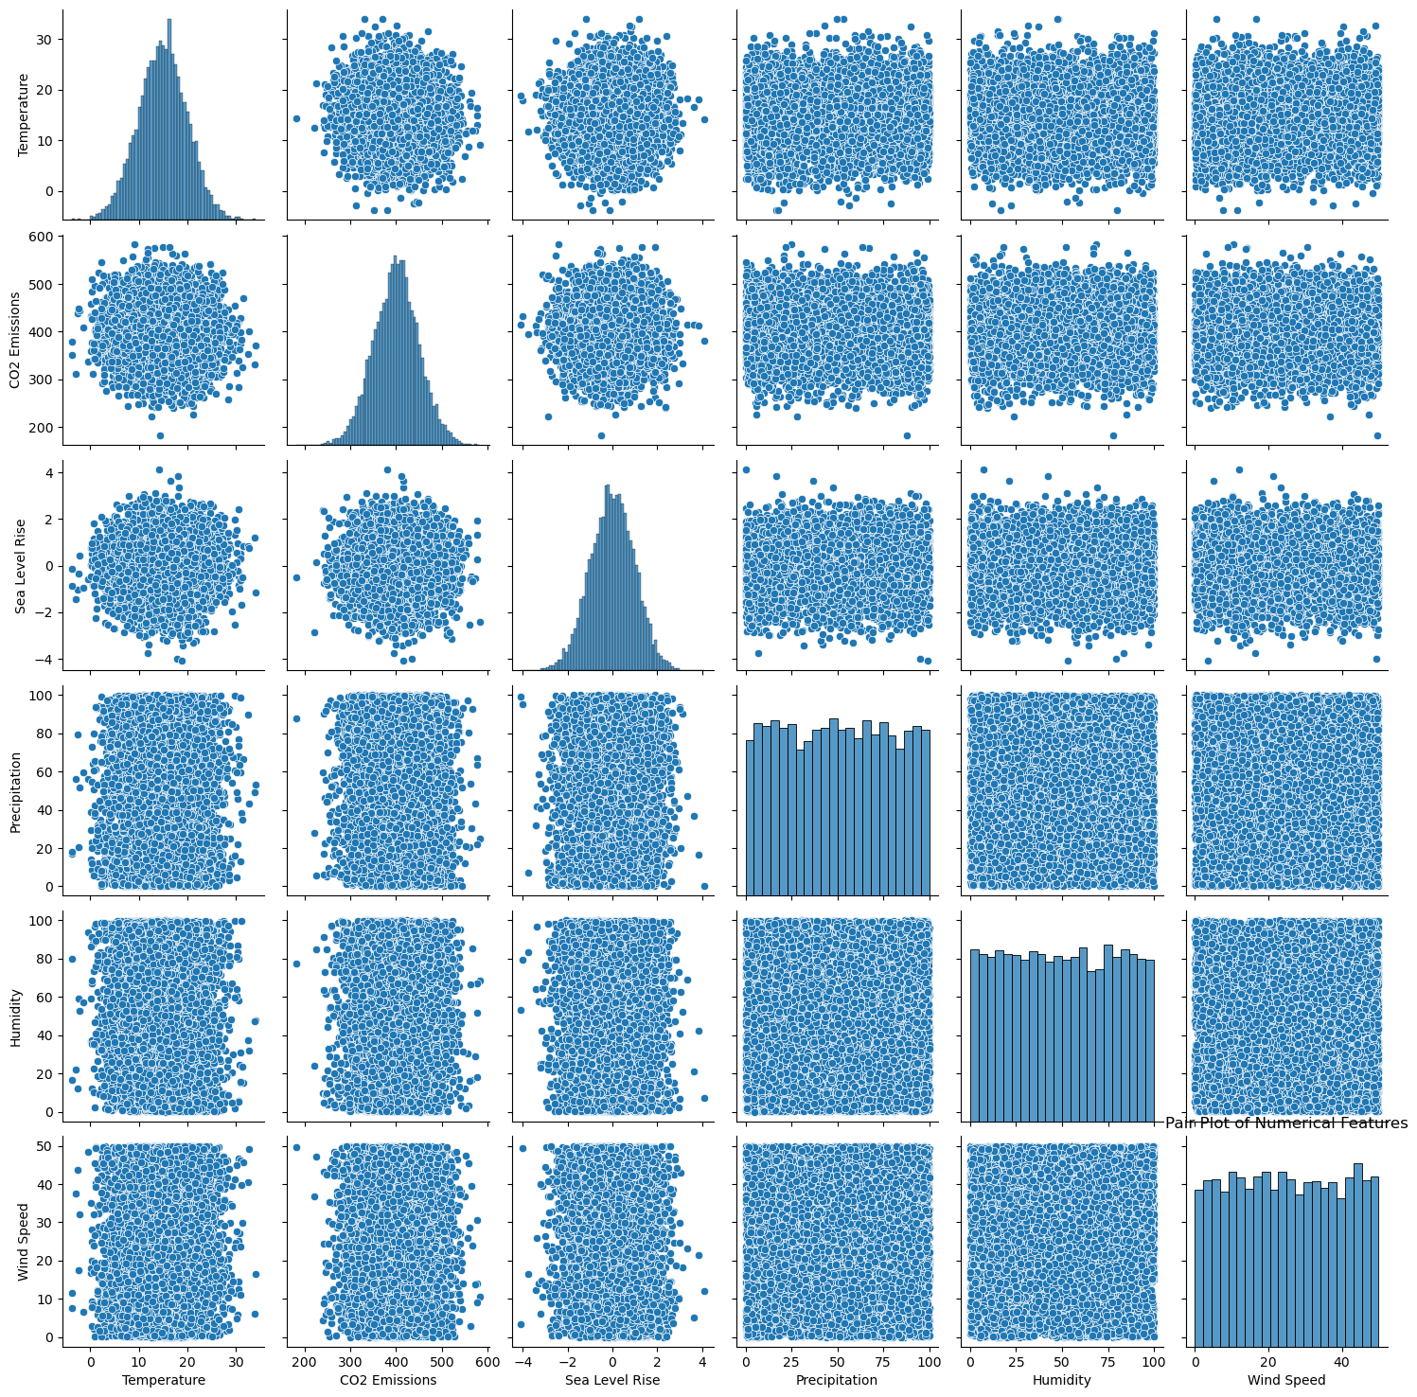

Figure 12: Pair Plot of Numerical Features

Figure 12 presents a pair plot for numerical features, including temperature, CO2 emissions, sea level rise, precipitation, humidity, and wind speed. This plot shows scatter plots for each pair of variables and histograms for individual variables, allowing for a comprehensive view of their relationships and distributions.

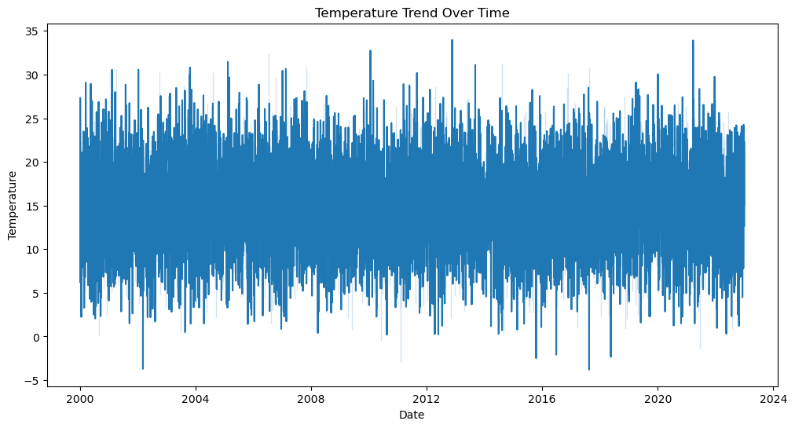

Figure 13: Temperature Trend Over Time

Figure 13 is a line plot tracking temperature changes over time. It connects temperature readings across dates to illustrate trends, seasonal variations, or long-term changes in temperature.

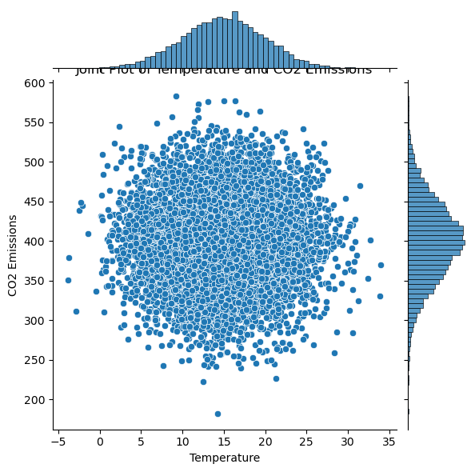

Figure 14: Joint Plot of Temperature and CO2 Emissions

Figure 14 shows a joint plot combining a scatter plot and marginal histograms for temperature and CO2 emissions. This plot provides a detailed view of their relationship and individual distributions, highlighting how these variables interact.

**CHAPTER 11**

**CONCLUSION AND FUTURE SCOPE**

The project effectively demonstrates the importance of advanced graphical data representation and analysis in understanding climate change. By leveraging various Exploratory Data Analysis (EDA) techniques, such as bar plots, box plots, scatter plots, and heatmaps, the project provides valuable insights into the relationships between climate variables like temperature, CO2 emissions, and precipitation. The detailed analysis reveals patterns, trends, and correlations that are crucial for comprehending the complex dynamics of climate change. Through these visualizations, researchers and policymakers can better interpret the impact of environmental factors and make informed decisions to address climate challenges. The integration of advanced visualization methods enhances the clarity and depth of climate data analysis, contributing to more effective strategies for climate change mitigation and adaptation.

**Future Scope**

* **Incorporation of Real-Time Data**: Integrate real-time data feeds to enhance the analysis with up-to-date information and improve the responsiveness to emerging climate trends.
* **Advanced Predictive Modeling**: Develop and apply machine learning models to predict future climate conditions based on historical data, enabling more accurate forecasts.
* **Interactive Dashboards**: Create interactive dashboards that allow users to explore different aspects of the data dynamically, providing a more user-friendly interface for analysis.
* **Geospatial Analysis**: Incorporate geospatial data to analyze climate patterns and trends across different geographical regions, enhancing spatial understanding of climate impacts.
* **Enhanced Data Granularity**: Include higher resolution data, such as finer time intervals and more detailed geographic information, to refine the analysis and uncover subtle patterns.
* **Cross-Variable Interaction Studies**: Investigate interactions between multiple climate variables to understand how they influence each other and contribute to broader climate phenomena.
* **Climate Impact Assessment**: Extend the analysis to assess the impact of climate change on specific sectors, such as agriculture, health, or infrastructure, to tailor adaptation strategies effectively.

**REFERENCES**

[1] R. Bayes, T. Bolsen, and J. N. Druckman, “A research agenda for climate change communication and public opinion: The role of scientific consensus messaging and beyond,” Environmental Communication, vol. 17, no. 1, pp. 16–34, 2023.

[2] Pew Research Center, “In response to climate change, citizens in advanced economies are willing to alter how they live and work,” <https://www.pewresearch.org/global/2021/09/14/in-response-to-climatechange-citizens-in-advanced-economies-are-willing-to-alter-how->theylive-and-work/ (accessed July 22, 2023), 2021.

[3] T. Brosch, “Affect and emotions as drivers of climate change perception and action: A review,” Current Opinion in Behavioral Sciences, vol. 42, pp. 15–21, 2021.

[4] A. Markman, “Why people aren’t motivated to address climate change,” https://hbr.org/2018/10/why-people-arent-motivated-to-addressclimate-change (accessed July 22, 2023), 2018.

[5] S. Joslyn and R. Demnitz, “Explaining how long CO2 stays in the atmosphere: Does it change attitudes toward climate change?” Journal of

Experimental Psychology: Applied, vol. 27, no. 3, pp. 473–484, 2021.

[6] B. W. Head, “Wicked problems in public policy,” Public Policy, vol. 3, no. 2, pp. 101–118, 2008.

[7] J. Johansson, T.-S. S. Neset, and B.-O. Linnér, “Evaluating climate visualization: An information visualization approach,” in 14th International

Conference on Information Visualisation, 2010, London, UK, E. Banissi, S. Bertschi, R. A. Burkhard et al., Eds. IEEE Computer Society, 2010, pp. 156–161.

[8] S. J. O’Neill and N. Smith, “Climate change and visual imagery,” WIREs Climate Change, vol. 5, no. 1, pp. 73–87, 2014.

[9] M. Mann, The hockey stick and the climate wars. Columbia University Press, 2012.

[10] B. Schneider, “Climate model simulation visualization from a visual studies perspective,” WIREs Climate Change, vol. 3, no. 2, pp. 185–193, 2012.

[11] IPCC, “Summary for Policymakers,” in Climate Change 2021: The Physical Science Basis. Contribution of Working Group I to the Sixth Assessment Report of the Intergovernmental Panel on Climate Change, V. MassonDelmotte, P. Zhai, A. Pirani et al., Eds. Cambridge, United Kingdom and New York, NY, USA: Cambridge University Press, 2021.

[12] M. Böttinger, H.-N. Kostis, M. Velez-Rojas, P. Rheingans, and A. Ynnerman, “Reflections on visualization for broad audiences,” in Foundations of Data Visualization, M. Chen, H. Hauser, P. Rheingans, and G. Scheuermann, Eds. Cham: Springer International Publishing, 2020, pp. 297–305.

[13] B. Lee, E. K. Choe, P. Isenberg, K. Marriott, and J. Stasko, “Reaching broader audiences with data visualization,” IEEE Computer Graphics and Applications, vol. 40, no. 2, pp. 82–90, 2020.

[14] E. M. Peck, S. E. Ayuso, and O. El-Etr, “Data is personal: Attitudes and perceptions of data visualization in rural Pennsylvania,” in Proceedings of the 2019 CHI Conference on Human Factors in Computing Systems, CHI 2019, Glasgow, Scotland, UK, May 04-09, 2019, S. A. Brewster, G. Fitzpatrick, A. L. Cox, and V. Kostakos, Eds. ACM, 2019.

[15] A. Burns, C. Lee, T. On, C. Xiong, E. Peck, and N. Mahyar, “From invisible to visible: Impacts of metadata in communicative data visualization,” IEEE Transactions on Visualization and Computer Graphics, pp. 1–16, 2022.

[16] J. H. Park, A. Kaufman, and K. Mueller, “Graphoto: Aesthetically pleasing charts for casual information visualization,” IEEE Computer Graphics and Applications, vol. 38, no. 6, pp. 67–82, 2018.

[17] H. Kennedy and R. L. Hill, “The feeling of numbers: Emotions in everyday engagements with data and their visualisation,” Sociology, vol. 52, no. 4, pp. 830–848, 2018.

[18] D. Sprague and M. Tory, “Exploring how and why people use visualizations in casual contexts: Modeling user goals and regulated motivations,” Information Visualization, vol. 11, no. 2, pp. 106–123, 2012.

[19] Z. Pousman, J. T. Stasko, and M. Mateas, “Casual Information Visualization: Depictions of Data in Everyday Life,” IEEE Trans. Vis. Comput. Graph., vol. 13, no. 6, pp. 1145–1152, 2007.

[20] S. Lee, S.-H. Kim, and B. C. Kwon, “VLAT: Development of a visualization literacy assessment test,” IEEE Transactions on Visualization and Computer Graphics, vol. 23, no. 1, pp. 551–560, 2017.